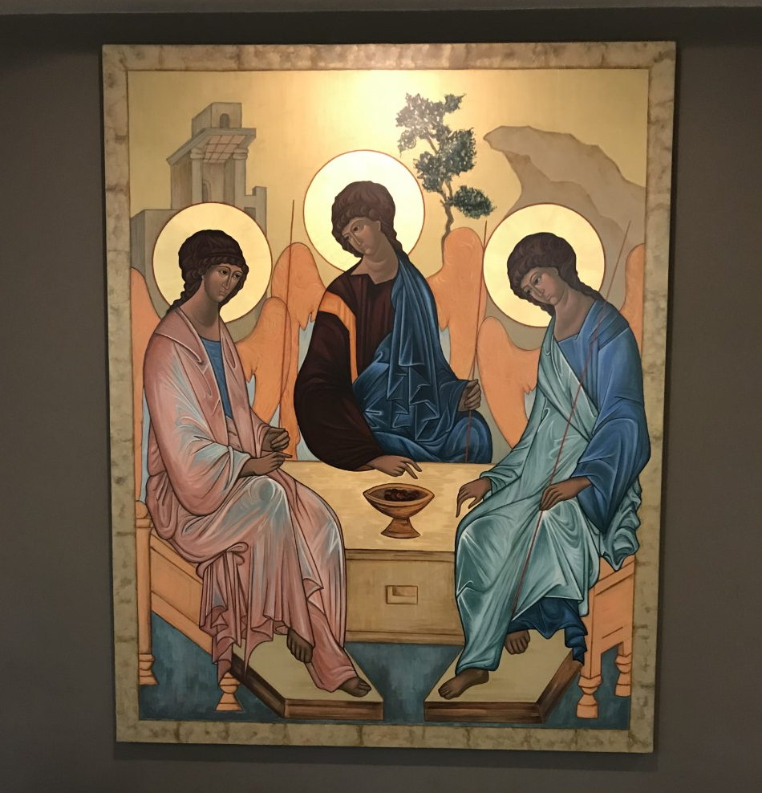https://www.benedictinecenter.org/Trinity-icon-e1592860735306.png

A REFLECTION ON THE HOLY TRINITY

EXODUS 34:4-9 JOHN 3:16-18 2 CORINTHIANS 13:11-13
The third chapter of John’s Gospel John proclaims that the Father loves the world and sent His Son to share eternal life with all who believe. The God, we contemplate today is present in, with and for us. The story of God’s love, Jesus, the Word Incarnate, draws us into His relationship with God as Father.
If you notice, Jesus as the “Son” is referred to three times in this passage, but the Holy Spirit is not mentioned. We come to know and recognize the Spirit in the love that is poured out into the world through the oneness of the Father and Son.
The first reading (Exodus 34:4-9) and the Gospel emphasize the power, mercy and love of God. In the second reading (2 Corinthians 13:11-13), Paul confirms that God is a “God of love and peace”. The reading from 2 Corinthians is the only one that mentions all three Persons of the Trinity. The Alleluia verse reminds us that all three Persons of the Trinity share in glory: “Glory to the Father, and the Son, and the Holy Spirit: To God who is, who was, and who is to come.”
A bit of interest: The Doxology was instituted in 1674. The Doctrine of the Holy Trinity was instated in the Third Century.

TRINITY OFFERS THE GIFT OF RELATIONSHIP
The Trinity offers us a precious gift of relationship, a grounded connection with God, self, others and the world. This Easter Season invited us to be in relationship with Jesus; it awakened us to a way of living, loving and relating.
We are invited to be like the Trinity-living in absolute relatedness.
During this pandemic, I realize more and more that we are all together in a web of mutual interdependence. When we recognize this on a spiritual level, we call it love.
We know it is through Love, we come to know God. As Christians we believe that God is revealed to us as a Trinity-three persons who are who they are because of how they love one another. It is in God’s nature to love, to reach out to all.

REFLECTING ON ANDREW RUBLEV'S ICON
This leads me to Andrew Rublev’s beautiful Icon in ous Dining Room. We see the Oneness of the three in this icon. They are a unity of persons in one divine nature. The Divine Persons are in relation to each other.
In his book, Behold the Beauty of the Lord: Praying With Icons, Henri Nouwen writes, “Rublev wrote this Icon not only to share the fruits of meditation on the mystery of the Holy Trinity but also to offer his fellow monks a way to keep their hearts centered in God while living in the midst of political unrest.” We certainly know that experience today.
Nouwen goes on to say: “Within the circle of the Holy Trinity, all true knowledge descends into the heart. The Russian mystics describe prayer as descending with the mind into the heart and standing there in the presence of God. Prayer takes place where heart speaks to heart, that is, where the heart of God is united with the heart that prays. Thus, knowing God becomes loving God, just as being known by God is being loved by God.”
Similarly, Pope Francis wrote the following in 2018: “The Feast of the Most Holy Trinity leads us to contemplate the mystery of God who unceasingly creates, redeems and Sanctifies, always with love and through love.”

REFLECTING ON THE DOXOLOGY AND THE RULE OF BENEDICT
This brings me to our daily Community liturgy. I was reflecting on the many times we pray the Doxology in our office (at least ten times). I am aware that sometimes I am not really paying attention to the words. I do the ritual of bowing and then go on. I desire to appreciate it. Pope Francis woke me up to the beauty of what I am praying. We have two forms for our doxology. This is the main one:
All honor to God, the Giver of Life, To Christ, the Risen One, And to the Spirit, Bond of Love Let Glory and Praise be Sung!
I was looking in the Rule of Benedict to see how and if he used the words Holy Spirit. I found he never used the name of Jesus, he used Christ, Christus many times, and a few times, Holy Spirit, Spiritu Sancto.
To site just two: In Chapter 7:70 his very last sentence on Humility:
All this the Lord will be the Holy Spirit graciously manifest in this workman now cleansed of vice and sin.
On the observance of Lent, in Chapter 49:6, Benedict uses Sancti Spiritus:
So that each of us will have something above the assigned measure to offer God of his own will, with the joy of the Holy Spirit.
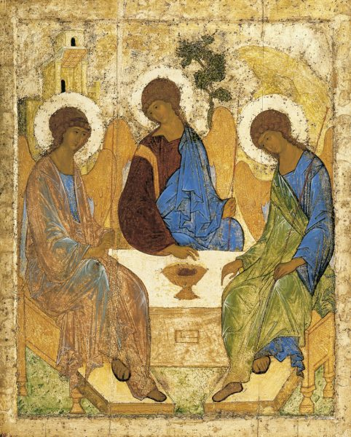

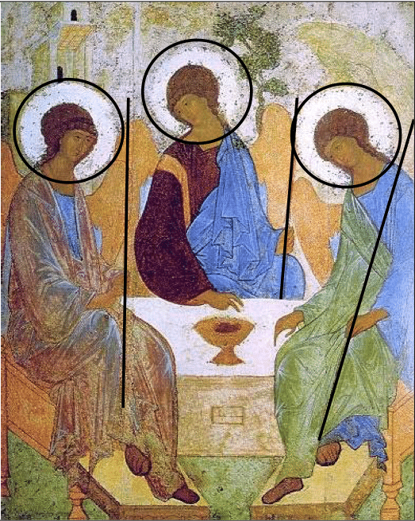
The Catechism 253 is clear in saying: The Trinity is One. We do not confess three Gods, but one God in three persons, the “consubstantial Trinity”.⁸³ The divine persons do not share the one divinity among themselves but each of them is God whole and entire. In the words of the Fourth Lateran Council (1215), “Each of the persons is that supreme reality, viz., the divine substance, essence or nature.
Symbolizing the fact that the three divine persons are of equal essence, we see:
– All three angels are the same in form and size
– All three carry the same staves in their hands
– All three sit on the same type of throne
– Each figure is clothed in the same types of garments – chiton and himation – which are individually distinct.
– The characteristic tone of the garments work with a limited palate of colors: purple, pale green, and the one color that is common to all three – an intense blue.

5. The divine persons are really distinct from one another.
The Catechism continues in number 254 to explain: “The divine persons are really distinct from one another. God is one but not solitary.” “Father”, “Son”, “Holy Spirit” are not simply names designating modalities of the divine being, for they are really distinct from one another. They are distinct from one another in their relations of origin: “It is the Father who generates, the Son who is begotten, and the Holy Spirit who proceeds.” The divine Unity is Triune.

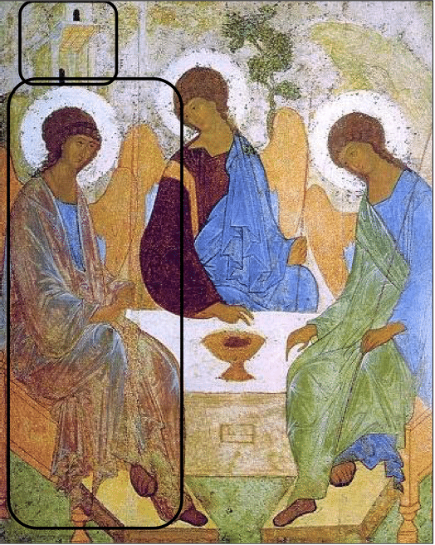
When speaking of icons, in reality, one doesn’t say that he or she has “painted” an icon. They are “written” and “read”, going from left to right. Let’s now take a look at each individual angel, beginning on the left, and try to recognize the particular aspects. We can distinguish the angel on the left from the others seeing that:
– He alone sits upright while the other two incline towards him.
– Seeing that the Father is still invisible for us, His form is almost completely veiled, allowing us to catch only a glimpse of the radiant blue (symbol of divinity) of His chiton. We can only hope to see him from “behind” through the beauty and wisdom of His creation which is here represented by the mantle. The mantle bears royal colors: gold and red with a greenish reflection, symbol of life.
– Both hands bear a firm grip on his stave which is pointed towards the earth. All authority of the heavens and the earth belong to Him.
– The house, rising immediately behind him, points to the Father, for “in my Father’s house are many rooms” (Jn 14:2). It is also a symbol of hospitality, seeing that Abraham and Sarah were recompensed for the hospitality that they offered. What does this tell us about the importance of hospitality?

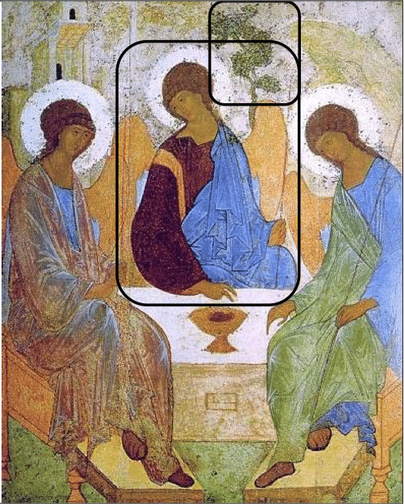
In the Icon, we can discover the following distinguishing characteristics of the son:
– He wears a dark purple chiton decorated with two – one of which is visible – stripes worked with gold. The costly purple and gold represent his being the “anointed of God,” king and prophet in one. The reddish brown color represents the earth and therefore his humanity. Christ is fully God and fully man.
– While the azure blue chiton of the Father is scarcely visible, that of the angel representing the Son is the prevailing color. This is because it is Jesus the Son that has revealed his “glory” which he has as the “only-begotten of the Father”. The disciples have seen and touched this (Jn 1.14) and the mission of every disciple is to bear testimony of this fact.
– The tree that rises behind the Son is a symbol of both the Tree of Life (from Genesis) and the Wood of the Cross. On the Cross the son transforms this tree of death into a tree of life whose fruits are passed on to us through our baptism in the Holy Spirit.
Let us always remember that we too are called to follow Christ along the paradoxical path of the cross that carries the sufferings of this world and allows this, through the Holy Spirit, to be transformed into new life

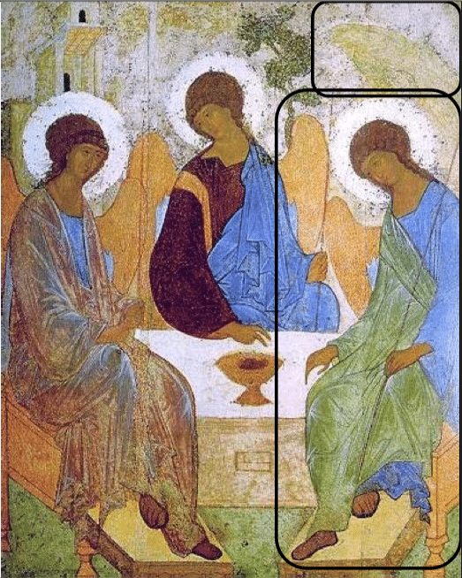
The Holy Spirit is always a tricky one to depict. While his personal being has been revealed, his countenance has not. The only thing we know about him is through his relationship to the Father and the Son.
– Like the Son, the Holy Spirit is inclined towards the Father, from whom he proceeds according to the teaching of the Bible (Jn 15:26).
– Like the Son, the chlamys is worn in such a way that leaves an arm free. Here, instead of the right arm, it is the left. Those follow the line of thinking proposed by St. Irenaeus who said that the Son and the Spirit are equally the two “hands” of the Father, through which he works everything.
– Like the son the heavenly azure blue is clearly seen.
– We also discover in his chlamys a pale green which, in Russia at least, is the liturgical color of Pentecost. Here the idea is that green represents new life in the Spirit who is the “Giver of Life” and who transmits and transforms our lives through our baptism. We see this same pale green on the ground on which all three figures find themselves.
– Finally, behind the angel we see a rock protruding. Like the Son and the Holy Spirit, the rock seems to be bowing down towards the authority and glory of the Father. We are invited to do the same.
– The rock can be understood as a symbol of earth, whose “face is renewed by the Spirit”. Earlier copies of the icon show that the rock was originally cracked which would lead us to recall the rock that was split by Moses’ staff, causing living water to flow out (Ex 17.6).
– The rock/mountain is also a privileged place to encounter God. There, heaven and earth embrace one another as they did when Moses encountered God on the mountain. It is a place there is often difficult to reach, requiring a certain silence, asceticism, and renunciation of the daily comforts the world and its routines offer us. We all need to keep an eye out for these “mountains” in our lives.

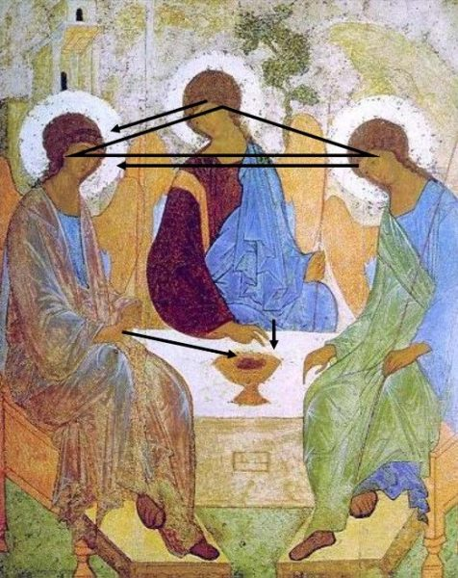

The Original Painting
Copyists and retouchers have made significant changes over the years. Originally, the Son’s hand was pointing towards the Holy Spirit, instead of the blessing gesture that we now see (Bunge says that he has seen what he considers to be the original gesture in older copies). The Son’s right hand seemed to point at the chalice; yet, at the same time, it points beyond towards the Spirit.
The artist’s attention was thus more directed at the Spirit. This is confirmed by the Father’s posture and gesture as he is looking at the Spirit, to whom his right hand, raised in blessing, is directed. The Spirit also seems to corroborate this in the fact that he humbly bows his head before the Father. His right hand also seems to want to underline this movement.

The Decisive Moment for our Salvation
Bunge’s consideration aside, I personally enjoy those who interpret this scene to be the moment when the Father decided to send the Son, through the Holy Spirit, to save humanity (us).
As we see in the image below, it is the Father, who is at the origin of it all, who calls the son and indicates the cup of sacrifice in the center of the table. The Son comprehends the Father’s will (to become man’s bread of life) and accepts, bowing his head and blessing the cup.
The Holy Spirit, also known as the Consoler, also accepts the will of the Father. He rests his hand on the table as he looks towards the Father, indicating his obedience to the Son (no one can call upon “Jesus Christ” without the Holy Spirit) and His trustful abandonment to the Father.

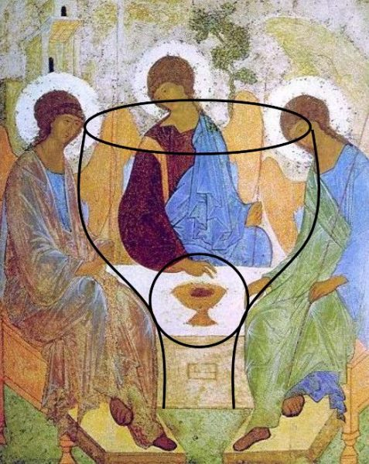
With careful observation, one can note how the middle angel seems to be contained within the shape of a cup whose contours are formed by the other two angels. Similar to the reflection just mentioned, here we see how the act of salvation is one of the Holy Trinity. As the Filarete, metropolitan of Moscow, once commented in 1816:
The cup, a point of convergence between the three, contains the mystery of love of the Father who crucifies, the love of the Son who is crucified, and the love of the Holy Spirit who triumphs with the force of the cross.
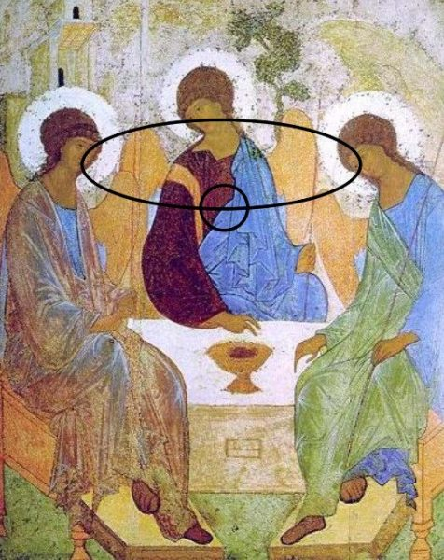
While the three figures form a circle, it is not closed in on itself. It is a circle of communion which opens and offers space for another. While their gaze is aimed towards one another, due to the reversed perspective, the faces are in some fashion facing the observer as well. As such, the spectator (that’s you and me), is invited and welcomed to participate as the fourth link in this mystical chain.
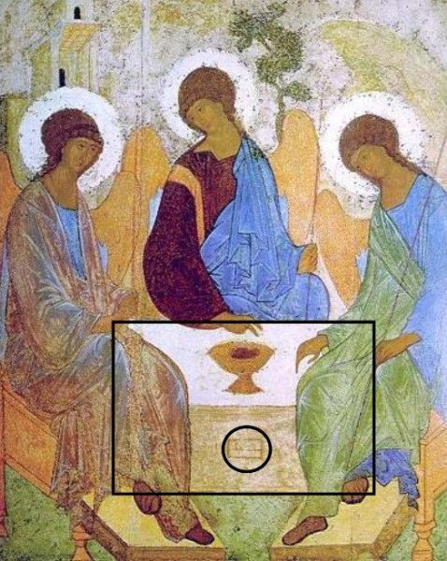
As we have just seen, in this Trinitarian circle of love, there is always space for another, and open space in which we are invited not only to observe but to participate.
At the center of the encounter, there is a table/alter where we also see a small box/window. This space is where relics of the martyrs are deposited.
When asking ourselves how we are called to participate, here and now, the icon invites us to participate in the celebration of the Eucharist (the altar) and to live our lives as martyrs, as witnesses of the resurrection who, following the school of Jesus, are willing to give our life for others and for the faith.

For this post, I have followed the presentation of Gabriel Bunge in his book The Rublev Trinity.
I have also consulted and used the images from the PDF offered by the Parrocchia di San Giorgio.

