
Romans 14:19
Let us then pursue what makes for peace and for mutual upbuilding.
A call to Pray for Peace in all Conferences.

As Vincentians, brothers and, sisters we are guided by the actions and life of St Vincent de Paul and his love for the poor. Our work is founded in Love and equality for all, the Love of Christ guides us to work towards a just and fair world.
As the tensions mount in the Middle East and the threat of all out conflict and war, let us hold in our prayers and thoughts those in our communities that have family, friends, and loved ones in Palestine, Gaza, Israel, Iran, Leabon and wherever war or conflict exist. Let our actions be guided by love as we encounter their fears and pain, may an open heart and the words of St Vincent de Paul guide us “Peace is worth far more than anything they may take from you.”
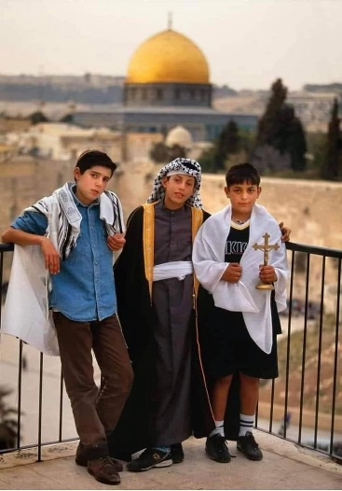
We are all called to strive for PEACE and as Vincentians we have a deeply rooted tradition of Spirituality and Prayer. In 2023 Pope Francis issued the following statement at the end of his weekly Angelus prayer
“Brothers and sisters, already many have died,” the Pope said. Please, let no more innocent blood be shed, neither in the Holy Land nor in Ukraine, nor in any other place! Enough! Wars are always a defeat, always! Prayer is the meek and holy force to oppose the diabolical force of hatred, terrorism, and war,”

[Cite your source here.]
Two peoples, one land, Three faiths, one root, One earth, one mother, One sky, one beginning, one future, one destiny, One broken heart, One God. We pray to You: Grant us a vision of unity. May we see the many in the one and the one in the many. May you, Life of All the Worlds, Source of All Amazing Differences Help us to see clearly. Guide us gently and firmly toward each other, Toward peace.
Amen.
Rabbi Sheila Weinberg Jewish Community of Amherst.
Some Prayers for Peace

Lord, Prince of Peace, here we are, we want to work together with you. Peace for the entire world is our request. Accept our cry for help, let us sense that you hear us, accompany our way of supplication, for we desire peace. Help us to build it. Give us peace, give us peace, give us peace.
Amen.
Pope Francis

Lord of mercy and compassion,
of grace and reconciliation,
pour your power upon all your children in the Middle East:
Jews, Muslims and Christians,
Palestinians and Israelis.
Let hatred be turned into love, fear to trust, despair to hope,
oppression to freedom, occupation to liberation,
that violent encounters may be replaced by loving embraces,
and peace and justice could be experienced by all.
- Reverend Said Ailabouni

Prayer of St Francis
Lord, make me an instrument of your peace; where there is hatred, let me sow love; where there is injury, pardon; where there is doubt, faith; where there is despair, hope; where there is darkness, light; and where there is sadness, joy. O Divine Master, grant that I may not so much seek to be consoled as to console; to be understood, as to understand; to be loved, as to love; for it is in giving that we receive, it is in pardoning that we are pardoned, and it is in dying that we are born to Eternal Life. Amen.

God of peace, bearer of hope, we seek your help for the peoples of the Middle East. Quiet the clamor of war and guide us towards peace. Where there is hatred and division sow seeds of calm and openness. Where there is destruction help us to rebuild. Where children are crying bring an end to tears. Shelter your peoples and protect them Guide them and keep them from harm. Show us how to break down the barriers of history and fear and breathe whispers of hope. Amen.
Linda Jones / CAFOD
A Prayer for Peace How do we pray for peace from half a world away? How can words salve and soothe real wounds, ease real fears, wipe tears from real eyes? God of endless compassion, transform our prayers from words into bridges, which span the distances between us, uniting our hearts in yours. Every time we turn our keys in a lock, may we remember all who are losing their homes. Every time we step into our cars, may we remember all who are having to flee. Every time we embrace our children, may we remember all who are trying to shield theirs from war. May our besieged sisters and brothers be drawn into the arms of the suffering Christ, and may our cry be heard as one voice, ringing out from every corner of the earth: God of endless mercy, grant us peace. Amen.
Cameron Bellm

