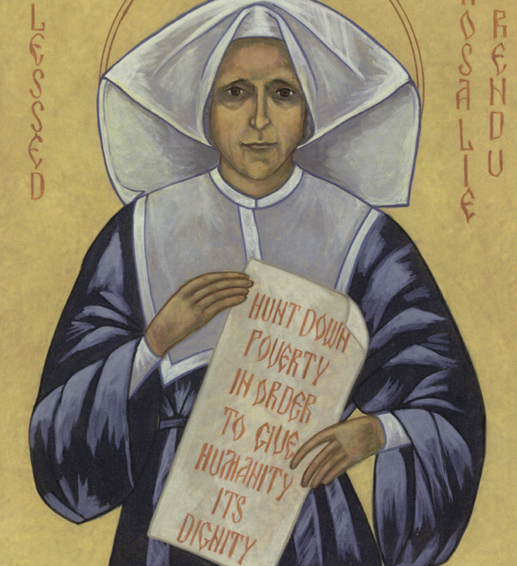
In her 54 years in the most poverty-stricken parts of Paris, Rosalie was a nurse, a justice of the peace, a catechist for the street children, and at the same time at the risk of her life she came between revolutionaries. Rosalie was the ‘good mother of all’ without distinction between religion, political persuasion, or social status. With one hand she received from the rich, with the other she gave to the poor. Every day, in all kinds of weather, Rosalie crisscrossed the streets and alleyways with her rosary in her hand and a heavy basket on her arm. She walked with hurried steps for she knew that the poor were waiting for her. Rosalie died on 7 February 1856, and was buried with all the trappings of a state funeral it was estimated that 50,000 people from all walks of life lined the streets of the funeral procession.
Blessed Rosalie Rendu Feast Day 7 February

“Remember that the poor person is more sensitive to proper treatment than help… Even if you have something with which to reproach him, studiously avoid all hurtful and cutting words.” Rosalie Rendu
In the days following the Revolution of 1830 the agitation of the people was great: anxiety, a thirst for a more just world, a desire for change in society and the commitment of Catholics. Emmanuel Bailly presented Frederic Ozanam and his group with a guide in Rosalie. She taught them how to visit the poor. She would give them advice on the Christian way to go to them, to respect them and to consider them as brothers and sisters, rich in humanness. With her they learned to see the face Christ in the poor. During the days of rioting by a violently angry working class in 1830 and 1848, barricades and bloody battles were the marks of opposition to the powerful. Rosalie was deeply grieved, and she herself climbed barricades to try and help the wounded fighters irrespective of the side they were fighting on.

“But be kind and love, for love is your first gift to the poor. They will appreciate your kindness and your love more than all else that you bring them.”
Bl Rosalie 1833
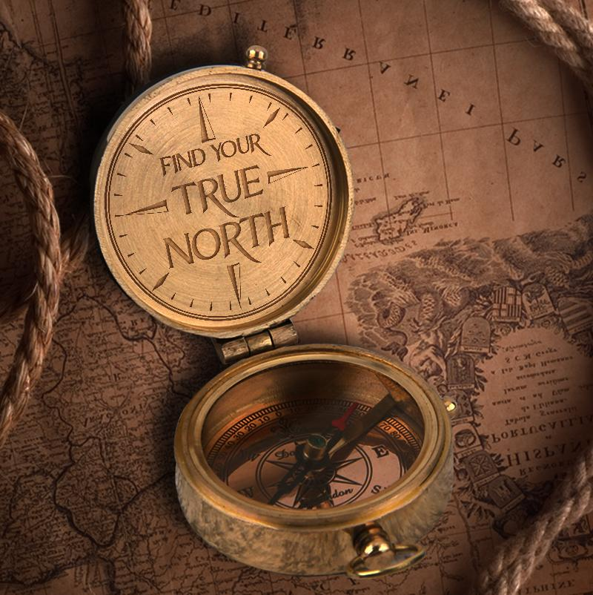

In what ways can you see the influence of Rosalie present
in the St Vincent de Paul Society of today?

