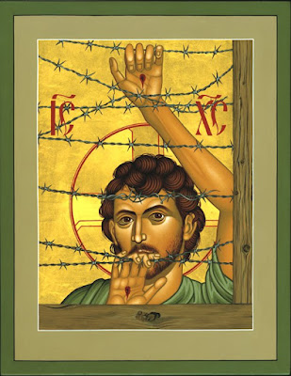
Befriending the stranger
Do not neglect to show hospitality to strangers, for by doing that some have entertained angels without knowing it. Hebrews 13:2
“See in the migrants of our time, as in those of every age, a living image of God’s people on their way to the eternal homeland,” writes Pope Francis in his 2024 Message for World Day of Migrants and Refugees.
In the novel The Little Prince by Antoine de Saint-Exupery, when the Little Prince meets the Fox, the two strangers have a conversation and in time they become friends as each has tamed the other and their own prejudice. The Little Prince missing his rose begins to understand and feel what love and truth are and how important it is to sit with and listen to the stranger and then what we perceived as different no longer matters as we are all interconnected in ways we do not realise. In his friendship with the Fox the Little Prince ponders his learning “The Fox showed me that sometimes the most valuable relationships are the ones that cannot be easily explained. Sometimes, the most beautiful things in life are the ones that cannot be seen. The Fox taught me the importance of trust and communication. Love is about accepting someone for who they truly are. The Fox taught me that true connection goes beyond words. Sometimes, it takes time and patience to truly understand someone. The Fox taught me that love is not about possession; it is about letting someone be free. Sometimes, the things we cannot see are the things that matter the most.”
I have been lucky enough to have semi tamed two Foxes and while they never came closer than 2 metres away they would stay around and play each day for about 20 min, like many before this experience I had a rather dim view of Foxes and saw them as a problem, yet once befriended they became a part of my human experience. An experience that enabled me to grow and see beauty in all of creation. As the Little Prince and Fox became tamed so did I. I waited for the Fox to turn up and would have chats (of course he understood every word), what mattered was someone was listening. I realised today that the Fox was also a refugee a hunted and often times finding itself having to flee from humans’ intent on its extermination. For me, the words of the Fox to the Little Prince are essential in my understanding of befriending the stranger, “People have forgotten this truth, but you mustn’t forget it. You become responsible forever for what you have tamed. It is only with the heart that one can see rightly.”
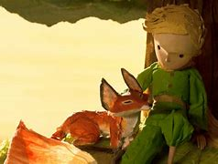
As Vincentians we too seek to befriend the strange, the alien in an alien land. We are called to show hospitality, help and be the bearers of compassion and love, just as the founders of the Society did. Like the Little Prince we are called to tame the fears, hurts and loneliness of the stranger and to embrace them as friend, companion, and family. As in the picture below of the Little Prince and the Fox we are to be there to offer support and comfort. In the words of the little Prince “It’s the time you spent with the fox that makes it special...... The fox taught me the importance of trust and communication. Love is about accepting someone for who they truly are. The fox taught me that true connection goes beyond words.” As we reach out too the poor, the needy, and the refugee let us carry these words of the Fox in our hearts, “What is essential is invisible to the eye. One sees clearly only with the heart.” As in the last picture the Fox and Little Prince are happy just to be with each other. That is our mission as Vincentians to be there for the strange and invite them into a healing friendship.

