FACTSHEET
When to refer people to Care financial counselling

Introduction
Care’s Vision is Financial Fairness For All. To give effect to this, our financial counselling program supports people in Canberra and surrounding areas who are experiencing financial challenges. ​

The demand for financial counselling appointments generally outweighs capacity. This puts stress on our financial counsellors, puts upward pressure on wait times and creates barriers to engagement. For this reason, it is crucial that we ensure financial counselling appointments are reserved for those that need it the most.

Key points
- It is vital that the allocation of financial counselling resources is based on need.
- Not all people experiencing financial difficulty need the same level of support.
- Some people experiencing financial difficulty are not ready or willing to engage with support.
- People that are seeking help can speak with a financial counsellor over the phone by calling the National Debt Helpline or by the NDH chat.

Options
Our financial counselling service is designed to be flexible and responsive to the needs and unique circumstances of the person seeking support. We apply a consistent approach to ensure access to financial counselling appointments is fair and equitable.

We consider indicators of need to assess whether a person really needs an appointment with a financial counsellor. We also consider how we could support them in other ways, including providing information and resources to understand their options and develop their own plan to manage debts.

Priority for financial counselling appointments is given to people with very high and high needs.
Triangle of need
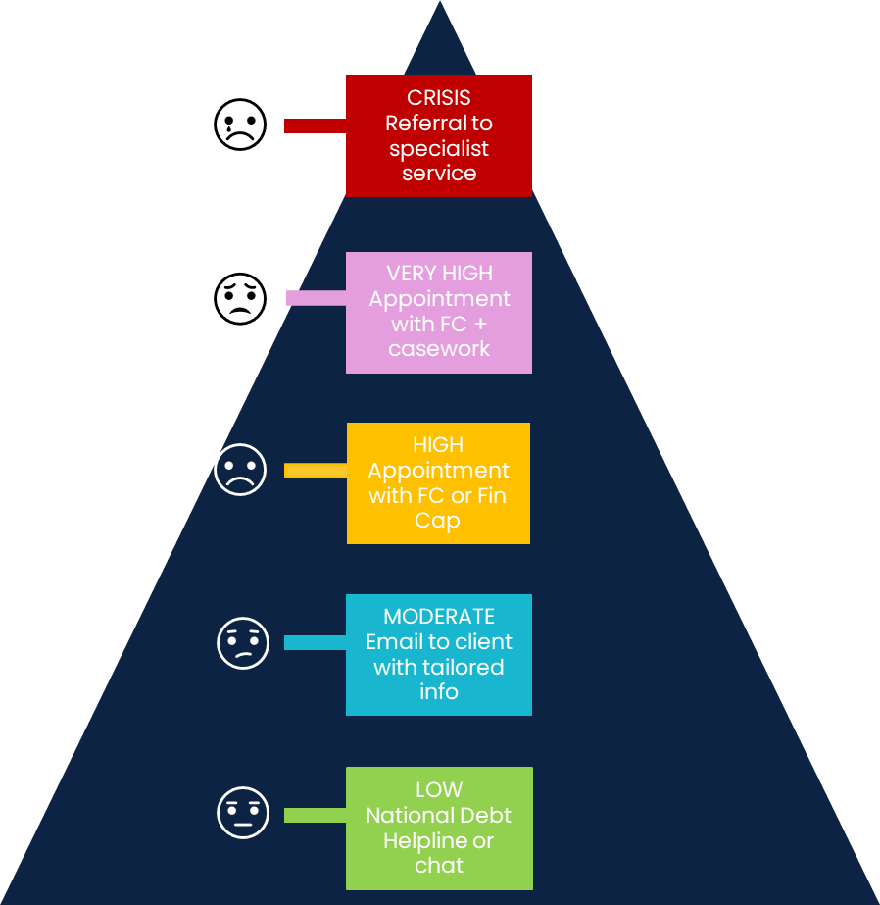

Very high need indicators may include:
- financial issues are affecting mental or physical health
- decision making difficult
- not in a position to advocate for themselves
- complex circumstances
- time critical debt issues
- history of trauma

High need indicators may include:
- feeling overwhelmed
- have a time critical issue
- situation may be worsening
- already tried some different things
- not sure what to do next
- feel unable to make a decision or move forward

While appointments with a financial counsellor have to be reserved for those that need it the most, anyone experiencing financial challenges can speak with a financial counsellor over the phone by calling the National Debt Helpline on 1800 007 007 or the NDH chat.

Examples

When to refer to financial counselling
Partner organisations should consider making a referral to Care financial counselling when the person they are supporting is experiencing indicators of high or very high need and is ready and willing to engage.

Financial recovery after escaping violence
A person has recently escaped domestic violence. They have debts that were directly related to financial abuse, as well as unpaid utility bills. The debts are making it difficult to move forward and are impacting the person’s mental health and wellbeing. They want to address them so that they can move forward and focus on their healing and recovery.

When to refer to the National Debt Helpline
Other people experiencing financial challenges can be referred to the National Debt Helpline.

General information about budgeting
A person is struggling with managing their bills and debt repayments and could benefit from learning about budgeting and money management. They have an adequate income, have the ability to engage with online resources and have no other financial vulnerability indicators. The person can speak with a financial counsellor on the National Debt Helpline about their situation and the budgeting tools and resources that may assist.

Information about ATO debt options
A person has a large income tax debt that they are unable to pay on time. They agree with the assessment but have not contacted the ATO about payment or hardship options. The person can speak with a financial counsellor on the National Debt Helpline about their situation and the options that may be available. The financial counsellor can provide information and resources to support the person via email so they can make an informed decision and have the confidence to contact the ATO for assistance.

For more information
Care Financial Counselling Referral Form

